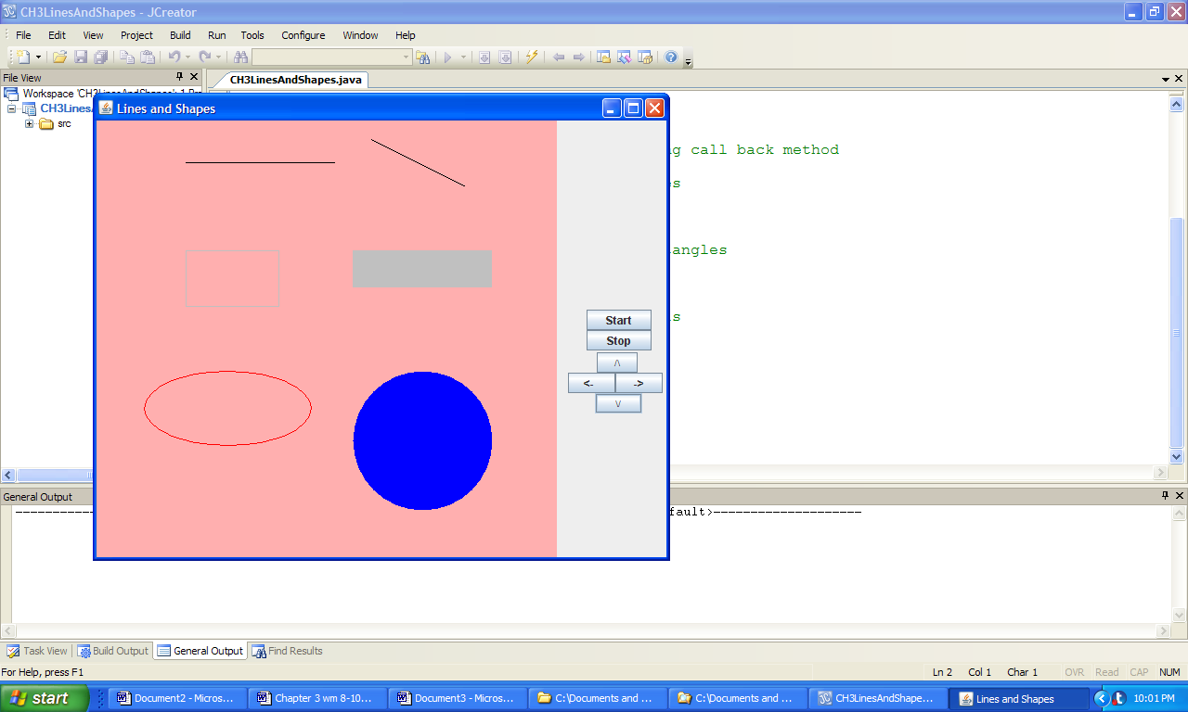

**Figure 3.9 The output produced by the application LinesAndShapes.**